- arr = [1, 2, 3, 7, 5], target = 12
এখানে ২য় থেকে ৪র্থ element (2 + 3 + 7 = 12) → Output: [2, 4]
• arr = [1, 2, 3, 4, 5, 6, 7, 8, 9, 10], target = 15
এখানে ১ম থেকে ৫ম element (1 + 2 + 3 + 4 + 5 = 15) → Output: [1, 5]
• arr = [5, 3, 4], target = 2
কোনো subarray এর sum = 2 হয় না → Output: [-1]
class Solution {
public:
vector<int> subarraySum(vector<int>& arr, int target) {
int start = 0;
int sum = 0;
for (int end = 0; end < arr.size(); end++) {
sum += arr[end];
while (sum > target && start <= end)
sum -= arr[start++];
if (sum == target) {
return {start+1, end+1};
}
}
return {-1};
}
};
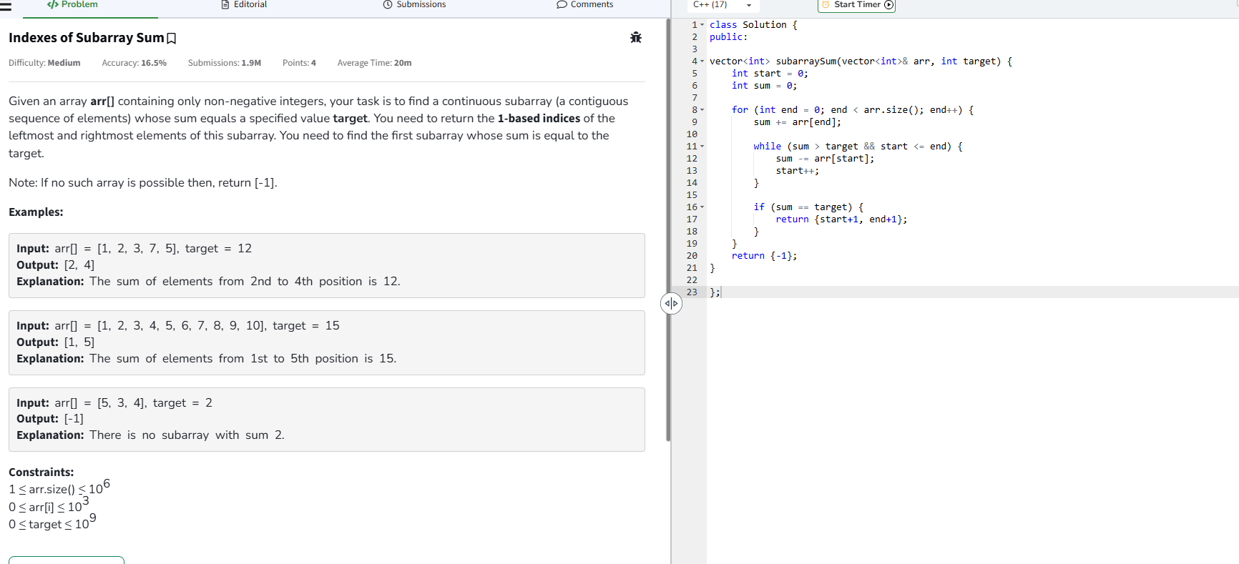

1. Two Sum
Given an array of integers nums and an integer target, return indices of the two numbers such that they add up to target.
You may assume that each input would have exactly one solution, and you may not use the same element twice.
You can return the answer in any order.

Example 1:
Input: nums = [2,7,11,15], target = 9
Output: [0,1]
Explanation: Because nums[0] + nums[1] == 9, we return [0, 1].
Example 2:
Input: nums = [3,2,4], target = 6
Output: [1,2]
Example 3:
Input: nums = [3,3], target = 6
Output: [0,1]
#include <iostream>
using namespace std;
void twoSum(int nums[], int n, int target) {
for(int i = 0; i < n; i++) {
for(int j = i + 1; j < n; j++) {
if(nums[i] + nums[j] == target) {
cout << "[" << i << "," << j << "]" << endl;
return; // exit after finding solution
}
}
}
cout << "No solution found" << endl;
}
int main() {
int nums1[] = {2,7,11,15};
int n1 = sizeof(nums1)/sizeof(nums1[0]);
int target1 = 9;
twoSum(nums1, n1, target1); // Output: [0,1]
int nums2[] = {3,2,4};
int n2 = sizeof(nums2)/sizeof(nums2[0]);
int target2 = 6;
twoSum(nums2, n2, target2); // Output: [1,2]
int nums3[] = {3,3};
int n3 = sizeof(nums3)/sizeof(nums3[0]);
int target3 = 6;
twoSum(nums3, n3, target3); // Output: [0,1]

return 0;
}
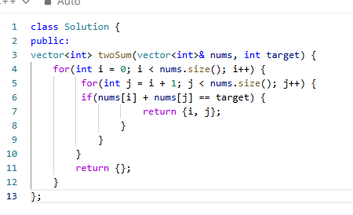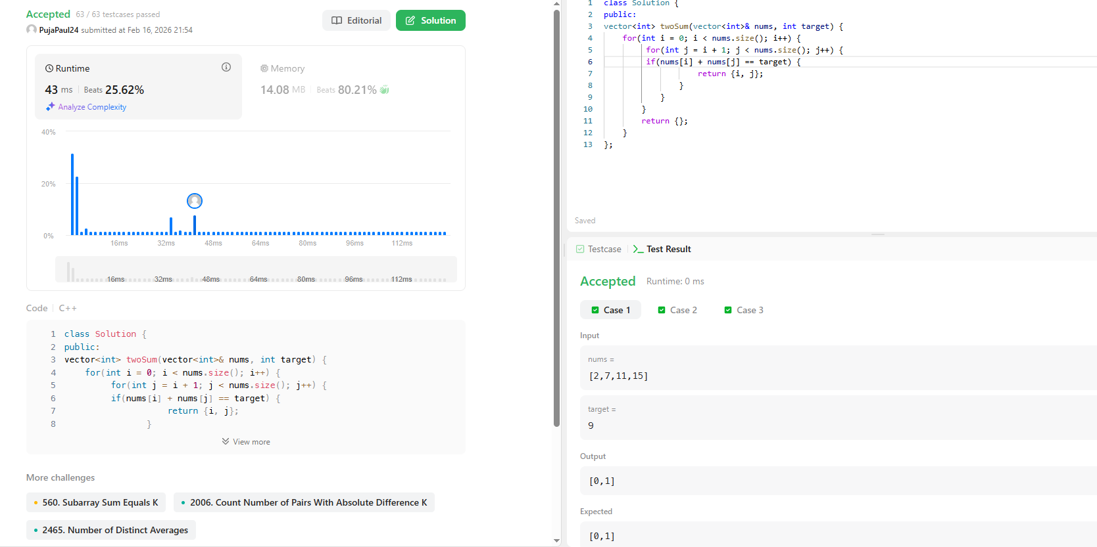

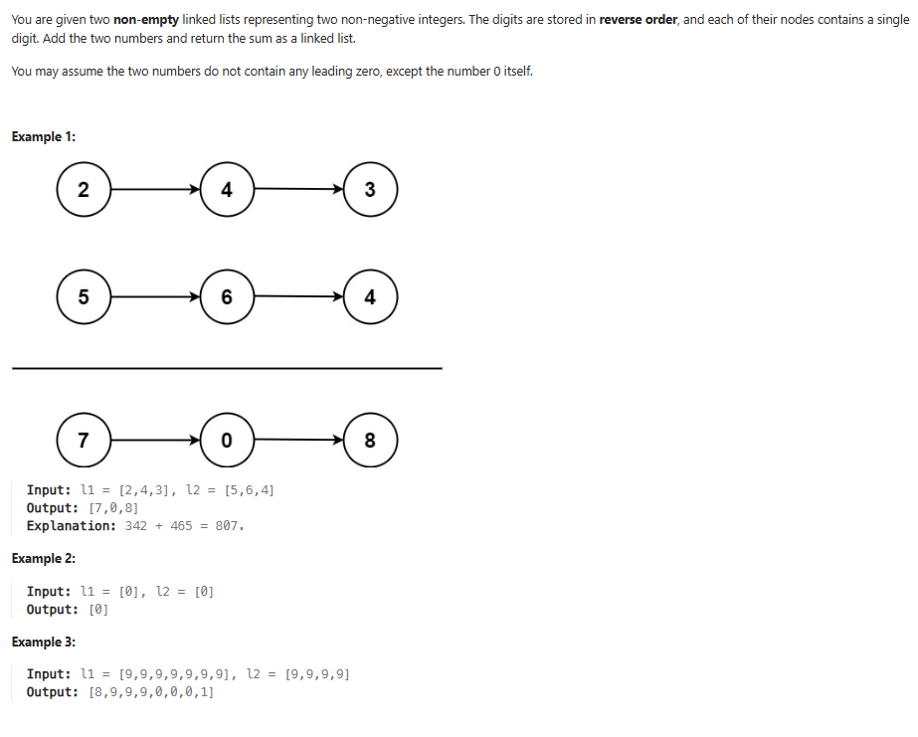
class Solution {
public:
ListNode* addTwoNumbers(ListNode* l1, ListNode* l2) {
ListNode* dummy = new ListNode(0); // starting node
ListNode* current = dummy;
int carry = 0;
while (l1 != NULL || l2 != NULL || carry != 0) {
int sum = carry;
if (l1 != NULL) {
sum += l1->val;
l1 = l1->next;
}
if (l2 != NULL) {
sum += l2->val;
l2 = l2->next;
}
carry = sum / 10; // carry বের করা
current->next = new ListNode(sum % 10); // digit রাখা
current = current->next;
}
return dummy->next; // dummy বাদ দিয়ে result return
}
};

🧮 Given Linked Lists
Linked List | Reverse Representation | Actual Number
2 → 4 → 3 | 3 4 2 | 342
5 → 6 → 4 | 4 6 5 | 465
লিস্টে সংখ্যা উল্টা (reverse order) থাকে।
প্রথম নোড = এককের ঘর।
Step | l1 Digit | l2 Digit | Previous Carry | Sum | Digit Written (sum % 10) | New Carry (sum / 10) | Result List
1 | 2 | 5 | 0 | 7 | 7 | 0 | 7
2 | 4 | 6 | 0 | 10 | 0 | 1 | 7 → 0
3 | 3 | 4 | 1 | 8 | 8 | 0 | 7 → 0 → 8

✅ Final Result
7 → 0 → 8
🔎 Check (Normal sum)
 | 342
+ | 465
= | 807

🎯 Exam / Interview Revision Trick
- digit রাখবো → sum % 10
- carry রাখবো → sum / 10
- loop চলবে যতক্ষণ:
l1 || l2 || carry

